**

**FOR IMMEDIATE RELEASE**

**<<Affiliate>> celebrates World Financial Planning Day to raise awareness about the value of financial planning**

*Eighth annual World Financial Planning Day is 9 October*

**DENVER, COLO – DAY MONTH 2024 –** As the cost of living continues to be a top financial concern for people around the world, <<Affiliate>> will join [Financial Planning Standards Board Ltd. (FPSB)](https://www.fpsb.org/) and its global network of organizations to host the eighth annual [World Financial Planning Day (WFPD)](https://worldfpday.org/) on 9 October to raise awareness about the wide-ranging benefits of financial planning and of working with a financial planner who has committed to rigorous standards of professionalism and to putting clients’ interests first. World Financial Planning Day will coincide with the International Organization of Securities Commissions (IOSCO) [World Investor Week (WIW)](https://www.worldinvestorweek.org/) from 7 to 13 October.

“We believe everyone deserves the opportunity to achieve financial well-being,” said FPSB CEO Dante De Gori, CFP. “Through World Financial Planning Day, we aim to help individuals discover the importance of financial planning to help build a brighter and more prosperous future for all.”

Last year, FPSB and its network reached out to more than 559 million people through media coverage, financial education events and social media as 21 territories around the world united to celebrate World Financial Planning Day. Building on this success, the 2024 campaign will include a variety of educational activities across the globe in observation of this year’s World Financial Planning Day to help increase financial literacy. Events and programs will be featured on the [WFPD website](https://worldfpday.org/global-events/) in September.

“In today’s complex financial environment, the importance of financial planning and of working with a CERTIFIED FINANCIAL PLANNER professional to develop a holistic financial plan cannot be overstated,” added De Gori. “Research* has shown that those who work with a financial planning professional are better off — reporting a better quality of life, enjoying more financial confidence and being more satisfied with their financial situation. We want individuals to realize the wide-ranging benefits of financial planning and are looking forward to hosting our eighth annual World Financial Planning Day, alongside IOSCO’s World Investor Week, to raise awareness of the transformative power of financial planning to give people financial security and freedom.”

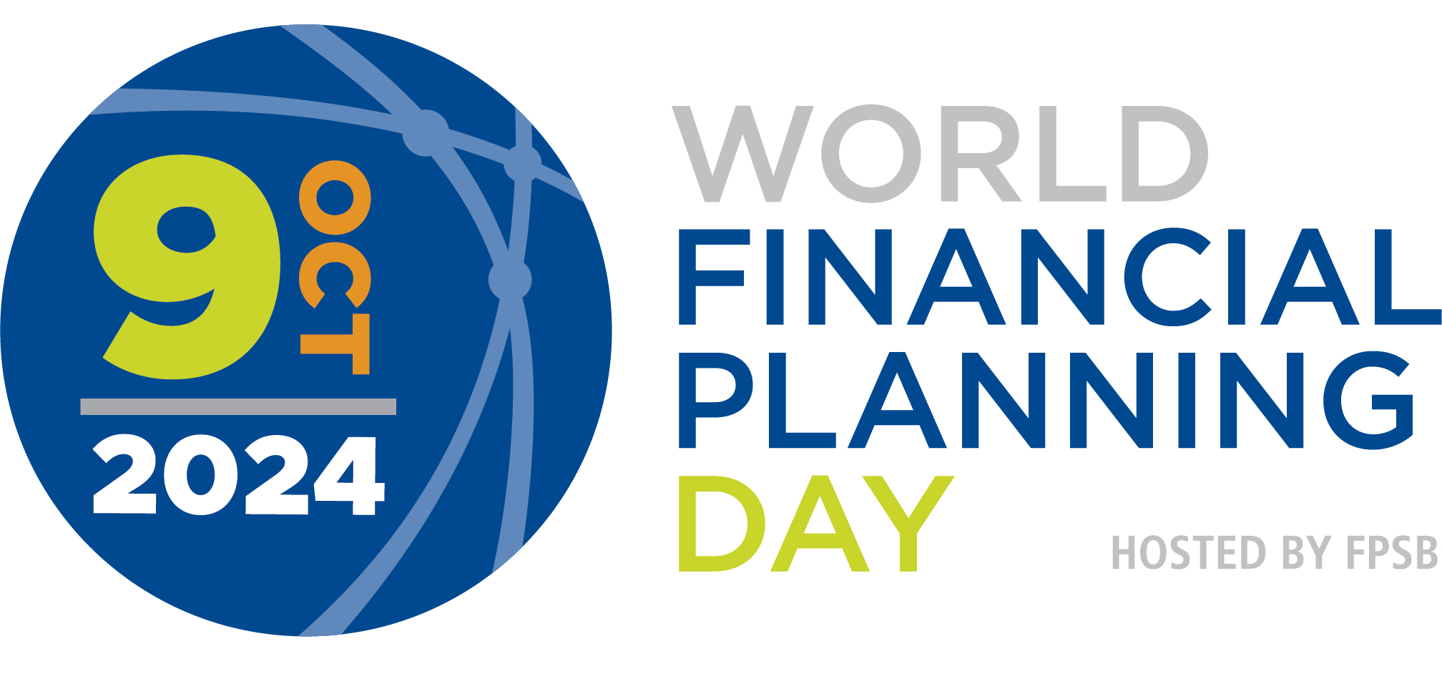

<<Affiliate>> is part of the FPSB Network, which represents more than 223,000 CFP professionals worldwide. <<Affiliate>> is proud to work with FPSB and its global network of organizations to celebrate World Financial Planning Day and support IOSCO’s World Investor Week to raise awareness about the importance of financial education and investor protection so individuals and families can achieve their life goals.

Since 2017, FPSB and its global network has celebrated World Financial Planning Day on the Wednesday of World Investor Week. Together, with international regulatory organizations, educational programs and resources are provided to help individuals make informed financial decisions and increase investor protection.

Tajinder Singh, Acting Secretary General at IOSCO, said: "We are pleased FPSB is hosting its eighth annual World Financial Planning Day in conjunction with our own World Investor Week again this year. Collaborating in this way emphasises our respective efforts to improve investor education and help people all around the world make more informed investment decisions."

“We are honored to continue our partnership with FPSB to support World Financial Planning Day as part of IOSCO’s World Investor Week,” said chair of IOSCO’s Committee on Retail Investors, Pasquale Munafò. “Through our work together over the past eight years, we are helping more people around the world gain the skills and knowledge needed to achieve investor and financial resilience and build brighter futures.”

More information about World Financial Planning Day and World Investor Week is available on [worldfpday.org](https://worldfpday.org) and [worldinvestorweek.org](https://www.worldinvestorweek.org/) and by joining the #WFPD2024 and #IOSCOWIW2024 conversations on [LinkedIn](https://www.linkedin.com/company/financial-planning-standards-board-ltd-), [Facebook](https://www.facebook.com/fpsb1/), [Twitter](https://twitter.com/fpsb), [Instagram](https://www.instagram.com/fpsb_global/) and [YouTube](https://www.youtube.com/user/FinancialPlanningSB).

**About <<Affiliate>>**

**About FPSB Ltd.**

FPSB manages, develops and operates certification, education and related programs to benefit the global community by establishing, upholding and promoting worldwide professional standards in financial planning. FPSB demonstrates its commitment to excellence with the marks of professional distinction – CFP, CERTIFIED FINANCIAL PLANNER and  – which it owns internationally. FPSB and our global network of organizations certify CFP professionals in 28 territories. CFP professionals reside in Australia, Austria, Brazil, Brunei, Canada, Chinese Taipei, Colombia, France, Germany, Hong Kong, India, Indonesia, Ireland, Israel, Italy, Japan, Macau, Malaysia, the Netherlands, New Zealand, People’s Republic of China, Republic of Korea, Singapore, South Africa, Switzerland, Thailand, the United Kingdom and the United States. There are over 223,000 CFP professionals worldwide. For more, visit [fpsb.org](https://www.fpsb.org/).

FPSB owns the CFP, CERTIFIED FINANCIAL PLANNER and  (the CFP Marks) outside the United States, and permits qualified individuals to use the marks to indicate that they meet FPSB’s initial and ongoing certification standards and requirements. CFP professionals may use the CFP marks in the territory or region in which they are certified.

**About CFP Certification**

CFP certification is the global symbol of excellence in financial planning and represents financial planners who commit to standards of competency and ethics, and to putting clients’ interests first. The CERTIFIED FINANCIAL PLANNER credential represents financial planning professionals who commit to better serving their clients through rigorous international standards, ethical practices and lifelong learning.

*\*See findings from* [*FPSB Value of Financial Planning Global Consumer Research 2023*](https://fpsb.org/about-financial-planning/the-value-of-financial-planning/?_gl=1%2A15bhfv1%2A_ga%2AMTk2MTI3NDkxNS4xNzE2OTEyMTY2%2A_ga_Y8ZDKSLZG5%2AMTcxNjkyNjY1MC4yLjAuMTcxNjkyNjY1MC42MC4wLjA.)

# # #

**CFP Certification** *Global excellence in financial planning™*

**Media Contact:**   
<<Name>>  
<<Title>>

<<Affiliate>>

<<Phone>>

<<Email>>