

Celebrating World Financial Planning Day: Global Activities to Raise Awareness on the Value of Financial Planning

Eighth annual World Financial Planning Day is 9 October

DENVER, COLO – 2 October 2024 – Financial planning is much more than managing money. To raise awareness about the wide-ranging benefits of financial planning, the Financial Planning Standards Board Ltd. (FPSB) is pleased to host the eighth annual World Financial Planning Day on 9 October in partnership with the International Organization of Securities Commissions (IOSCO) World Investor Week (WIW) from 7-13 October.

“We’re excited to come together with our global network and community of CERTIFIED FINANCIAL PLANNER professionals to raise awareness of the value of financial planning through World Financial Planning Day, hosted alongside IOSCO’s World Investor Week,” said FPSB CEO Dante De Gori, CFP. “Financial planning can not only play a key role in achieving long-term financial stability and success but also positively impact an individual’s mental health and family life. Through World Financial Planning Day, we strive for individuals worldwide to discover the powerful impact financial planning can have to achieve life goals and build brighter futures.”
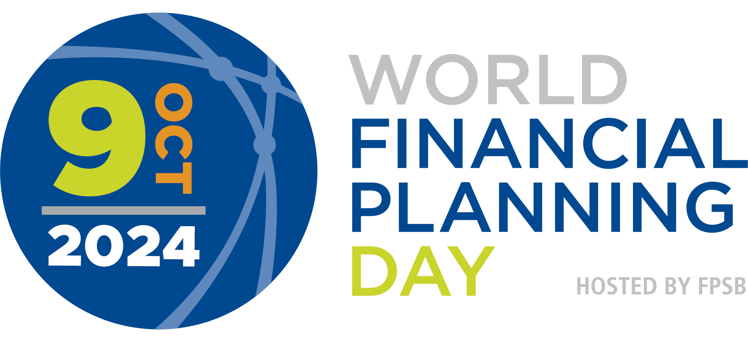

To mark this year’s campaign, FPSB and its global network of organizations, representing more than 223,000 CFP professionals worldwide, will share a celebratory campaign video, share FPSB’s Value of Financial Planning global consumer research findings, host a variety of financial education events and disseminate key messages to build awareness on the significant impact financial planning can have to achieve life goals and dreams. Activities include:

- Australia: Financial Advice Association Australia will host Financial Planning Week 2024 to highlight how its members help Australians to live well and release findings from its 2024 Value of Advice Index on 8 October.
- Canada: FP Canada will launch an extensive social media campaign to increase awareness of the value of financial planning and of working with a financial planning professional.
- China: FPSB China will launch an online campaign that shares research findings to build awareness of the value of financial planning and of working with a financial planning professional.
- Chinese Taipei: Financial Planning Association of Taiwan will host the World Investor Week Forum from 7-9 October to educate and inspire investors on the current and future state of the global financial economy.
- Germany: FPSB Deutschland will host a virtual roundtable that will include experts and financial planners to discuss financial trends and pension options specifically for women.
- Hong Kong: The Institute of Financial Planners Hong Kong is conducting a consumer survey to examine gender attitudes towards financial management.
- India: FPSB India will host the “India Financial Planning Conclave 2024” in association with the International Financial Services Authority on 4 October to share financial insights and strategies and address the dynamic challenges and opportunities India’s financial sector.
- Japan: Japan Association for Financial Planners will present at the Financial Planning Association of Taiwan’s World Investor Week Forum in October and share consumer research findings to raise awareness of the value of financial planning.
- New Zealand: Financial Advice New Zealand will raise awareness of the value of financial planning via its website, social media and news articles.
- Thailand: Thai Financial Planners Association will host a virtual financial planning clinic that will offer one-on-one pro bono financial planning consultations with CFP professionals and broadcast videos hosted by CFP professionals to educate the public on the value of financial planning.
- South Africa: Financial Planning Institute of Southern Africa will host a pro bono financial planning clinic, workshops and a media roundtable to raise awareness of the value of financial planning.
- United Kingdom: The Chartered Institute for Securities & Investment will host its annual in-person Financial Planning Conference to learn and discuss financial planning best practices and will raise awareness of the value of financial planning via social media and news articles.

We invite everyone to participate in our activities and take advantage of the resources available.

More information about World Financial Planning Day and World Investor Week is available on worldfpday.org and worldinvestorweek.org and by joining the #WFPD2024 and #IOSCOWIW2024 conversations on LinkedIn, Facebook, Twitter, Instagram and YouTube.

About FPSB Ltd.
FPSB manages, develops and operates certification, education and related programs to benefit the global community by establishing, upholding and promoting worldwide professional standards in financial planning. FPSB demonstrates its commitment to excellence with the marks of professional distinction – CFP, CERTIFIED FINANCIAL PLANNER and  – which it owns internationally. FPSB and our global network of organizations certify CFP professionals in 28 territories. CFP professionals reside in Australia, Austria, Brazil, Brunei, Canada, Chinese Taipei, Colombia, France, Germany, Hong Kong, India, Indonesia, Ireland, Israel, Italy, Japan, Macau, Malaysia, the Netherlands, New Zealand, People’s Republic of China, Republic of Korea, Singapore, South Africa, Switzerland, Thailand, the United Kingdom and the United States. There are over 223,000 CFP professionals worldwide. For more, visit fpsb.org.

FPSB owns the CFP, CERTIFIED FINANCIAL PLANNER and (the CFP Marks) outside the United States, and permits qualified individuals to use the marks to indicate that they meet FPSB’s initial and ongoing certification standards and requirements. CFP professionals may use the CFP marks in the territory or region in which they are certified.

About CFP Certification
CFP certification is the global symbol of excellence in financial planning and represents financial planners who commit to standards of competency and ethics, and to putting clients’ interests first. The CERTIFIED FINANCIAL PLANNER credential represents financial planning professionals who commit to better serving their clients through rigorous international standards, ethical practices and lifelong learning.
# # #
CFP Certification Global excellence in financial planning™

Media Contact:
Ryanne Harrah
Senior Manager of Communications and Content
Financial Planning Standards Board Ltd.
+1-720-203-7007
rharrah@fpsb.org

