

Territory Financial Planning Community to Celebrate
9th World Financial Planning Day on 8 October

Annual global initiative highlights the benefits of financial planning and of working with a
CFP professional

LOCATION – DAY OCTOBER 2025 – With 79% of consumers reporting that financial planning helps fulfil life dreams, Network Organization will join the Financial Planning Standards Board Ltd. (FPSB) and its global network across 28 territories to host the 9th World Financial Planning Day on 8 October 2025. The annual event demonstrates how financial planning – and working with a financial planner who has committed to competency and ethical standards – helps people worldwide achieve greater financial well-being.

Launched in 2017 as part of the International Organization of Securities Commissions’ (IOSCO) World Investor Week, World Financial Planning Day unites the global financial planning community to raise awareness about the value of financial planning and the benefits of working with a CERTIFIED FINANCIAL PLANNER professional.

“World Financial Planning Day shines a spotlight on how financial planning can transform lives. With more than 230,000 CFP professionals worldwide, we’re proud to join our global community to raise awareness of the importance of financial planning during this annual celebration, held alongside IOSCO’s World Investor Week,” said FPSB CEO Dante De Gori, CFP. “Through World Financial Planning Day, we want individuals everywhere to discover the powerful role financial planning can play in reaching life goals and shaping a more confident future.”
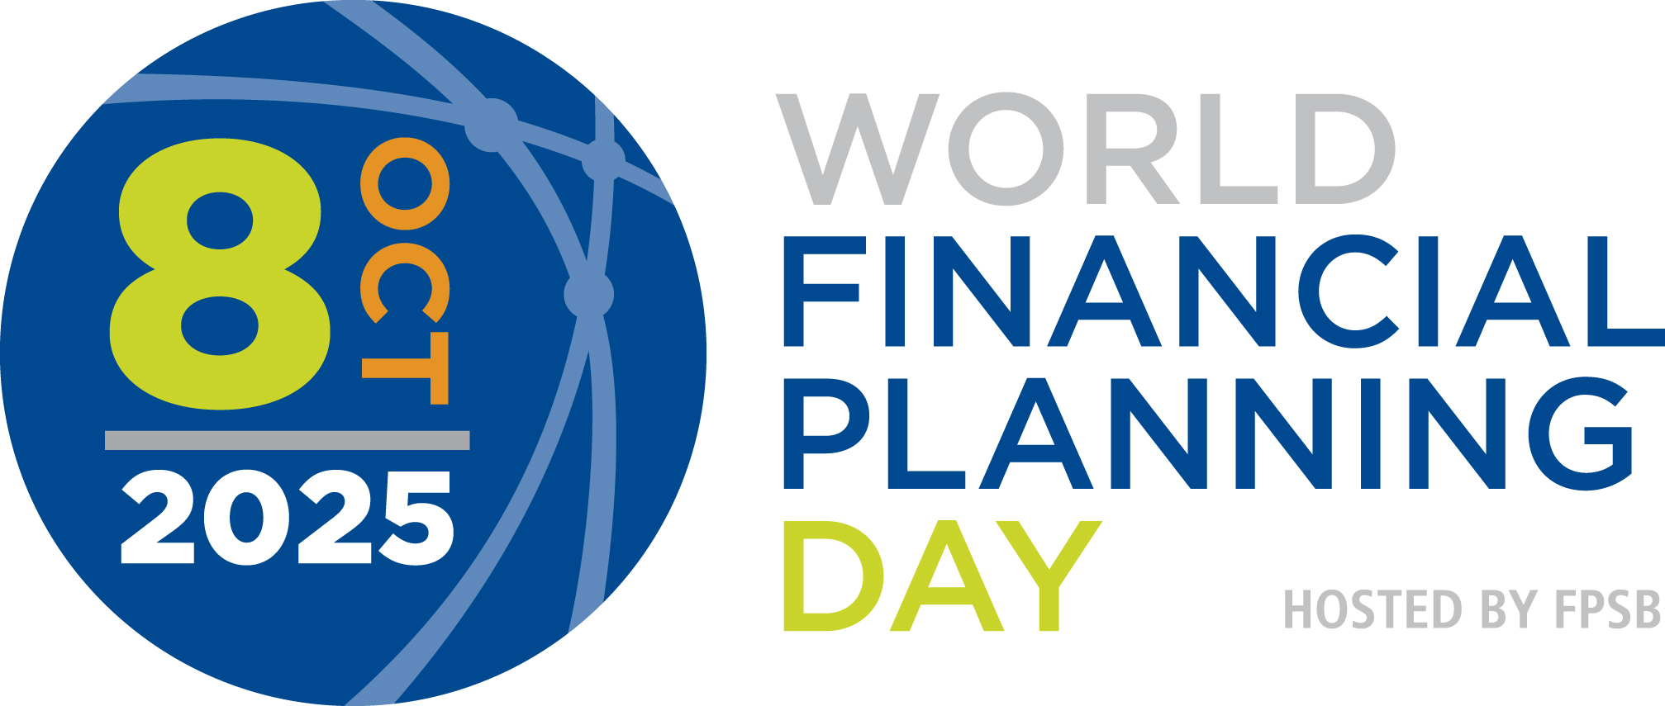

Activities in <<your territory>>

To mark this year’s campaign, Network Organization representing more than # CFP professionals in territory will host financial education initiatives and disseminate key messages to build awareness of the importance of financial planning. Activities include:

- <<Activity # 1>>
- <<Activity # 2>>
- <<Activity # 3>>

More details of these activities are available on your website link.

New Videos Showcase Value of Financial Planning
To celebrate this year’s initiative, FPSB has released three videos featuring CFP professionals from around the globe. In these videos, professionals share perspectives on how financial planning changes lives and why clients who work with a CFP professional report a better quality of life, enjoy more financial confidence, and are more satisfied with their financial situation. Special contributions from FPSB CEO Dante De Gori, CFP, and IOSCO Secretary General Rodrigo Buenaventura highlight the importance of this annual initiative. View the videos here: Video 1, Video 2 and Video 3.

Global Celebratory Event

As part of this year’s celebration, FPSB will host a dedicated session and celebration on 8 October during the FPSB 2025 Global Meeting in Chicago (U.S.), where more than 70 leaders from the financial planning profession around the world will gather. The celebration will include guest remarks from IOSCO Retail Investors Committee Chairman Camille Beaudoin on how our joint efforts are raising awareness of the importance of financial planning and investor education and protection.

“This year’s World Financial Planning Day offers a unique opportunity to celebrate our global impact with leaders from across our network,” said FPSB CEO Dante De Gori, CFP. “Together, we’ll mark our shared commitment to raise awareness of the value of financial planning and the positive difference CFP professionals make in people’s lives around the world.”

Get Involved

Everyone is invited to take part in World Financial Planning Day 2025 activities. More information about World Financial Planning Day and World Investor Week is available on worldfpday.org and worldinvestorweek.org and by joining the #WFPD2025 and #IOSCOWIW2025 conversations on LinkedIn, Facebook, Twitter, Instagram and YouTube.

About Network Organization
Add your boilerplate

About FPSB Ltd.
FPSB manages, develops and operates certification, education and related programs to benefit the global community by establishing, upholding and promoting worldwide professional standards in financial planning. FPSB demonstrates its commitment to excellence with the marks of professional distinction – CFP, CERTIFIED FINANCIAL PLANNER and  – which it owns internationally. FPSB and our global network of organizations certify CFP professionals in 28 territories. CFP professionals reside in Australia, Austria, Brazil, Brunei, Canada, Chinese Taipei, Colombia, France, Germany, Hong Kong, India, Indonesia, Ireland, Israel, Italy, Japan, Macau, Malaysia, the Netherlands, New Zealand, People’s Republic of China, Republic of Korea, Singapore, South Africa, Switzerland, Thailand, the United Kingdom and the United States. There are over 230,000 CFP professionals worldwide. For more, visit fpsb.org.

FPSB owns the CFP, CERTIFIED FINANCIAL PLANNER and (the CFP Marks) outside the United States, and permits qualified individuals to use the marks to indicate that they meet FPSB’s initial and ongoing certification standards and requirements. CFP professionals may use the CFP marks in the territory or region in which they are certified.

About CFP Certification
CFP certification is the global symbol of excellence in financial planning and represents financial planners who commit to standards of competency and ethics, and to putting clients’ interests first. The CERTIFIED FINANCIAL PLANNER credential represents financial planning professionals who commit to better serving their clients through rigorous international standards, ethical practices and lifelong learning.
*See findings from FPSB Value of Financial Planning Global Consumer Research 2023

# # #
CFP Certification Global excellence in financial planning™
Media Contact:
Name
Title
Network Organization
Phone
Email

